The woman who was sick for 12 years
Reading: from Luke 8:43-48
A woman was there who had a sickness that made her bleed. Her sickness had lasted for 12 years. No-one could heal her. She came up behind Jesus and touched the edge of his clothes. Right away her bleeding stopped.
‘Who touched me?’ Jesus asked.
Everyone said they didn’t do it. Then Peter said, ‘Master, the people are crowding and pushing against you.’
But Jesus said, ‘Someone touched me. I know that power has gone out from me.’
The woman realised that people would notice her. Shaking with fear, she came and fell at his feet. In front of everyone, she told why she had touched him. She also told how she had been healed in an instant. Then he said to her, ‘Dear woman, your faith has healed you. Go in peace.’
Thought about the reading
If you are ill for a long time, it can make you feel very sad. The woman in the story had been ill for 12 years. She had spent all her money paying doctors, but they could not help her. In those days, people who were bleeding were thought to be ‘unclean’, so she probably did not have any friends. She must have been sad and lonely.
She believed that if she just touched the edge of Jesus’ clothes, she would be better. And that is what happened! Jesus made her better! That changed her life. Now she could go out and meet people. She could stop feeling sad.
When we are ill and feel sad, we can tell Jesus about it. We know that he will hear us. He may not make us better in the same way as the woman, but he will help us. He will give us strength to keep going. He will give us friends to look after us. And he gives us hope that one day all our sicknesses will be over.

Prayer
Dear Jesus, thank you that you changed the woman when you made her better.
When I am ill and feeling sad, please help me to trust you and to remember that you are always with me, looking after me.
Amen

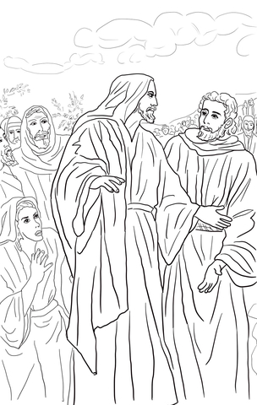

Cambridge Causeway

Spring 2025
Bible Study notes

People changed by Jesus
3. The woman who was sick for 12 years
By Chrissy Cole

